EXPERIMENT - 8
AIM:
A] To illustrate how memory is allocated to processes using MVT and MFT techniques, and to observe the differences in memory utilization, fragmentation, and process execution efficiency.
B] To implement and compare Best Fit, First Fit, and Worst Fit memory allocation strategies in dynamic partitioning, and to analyze their efficiency in allocating memory blocks to processes.

TOOLS/SOFTWARES REQUIRED: CPU-OS simulator

THEORY: Operating Systems manage computer resources and coordinate the execution of multiple programs to ensure efficient and reliable system performance. One of the key responsibilities of an operating system is process scheduling, which determines the order in which processes access the CPU. Various scheduling algorithms such as First Come First Serve (FCFS), Shortest Job First (SJF), Priority Scheduling, and Round Robin are used to optimize CPU utilization, reduce waiting time, and improve overall system responsiveness.
Another important function of an operating system is thread creation and synchronization. Threads are lightweight units of execution within a process that allow multiple tasks to run concurrently. However, when multiple threads access shared resources, synchronization mechanisms such as mutexes, semaphores, and monitors are used to prevent conflicts and maintain data consistency.
The operating system must also manage situations known as deadlocks, where two or more processes are unable to proceed because each is waiting for resources held by the other. Deadlock management techniques include prevention, avoidance, detection, and recovery. Algorithms like the Banker’s Algorithm help avoid unsafe states by ensuring that resource allocation does not lead to deadlock conditions.
In this experiment, a CPU-OS simulator is used to study and analyze these core operating system concepts. By simulating different scheduling strategies, thread operations, and deadlock handling techniques, students can observe how operating systems maintain efficient process execution, safe resource sharing, and stable system operation.

CODE:

MFT
#include <stdio.h>

int main() {
int m, n, i, j;

printf("Enter number of partitions: ");
scanf("%d", &m);

printf("Enter number of processes: ");
scanf("%d", &n);

int partition[m], process[n], allocated[m];

// Initially all partitions are free
for(i = 0; i < m; i++)
allocated[i] = 0;

printf("Enter partition sizes:\n");
for(i = 0; i < m; i++)
scanf("%d", &partition[i]);

printf("Enter process sizes:\n");
for(i = 0; i < n; i++)
scanf("%d", &process[i]);

printf("\nProcess No.\tProcess Size\tPartition No.\n");

for(i = 0; i < n; i++) {
int flag = 0;
for(j = 0; j < m; j++) {
if(!allocated[j] && process[i] <= partition[j]) {
printf("%d\t\t%d\t\t%d\n", i+1, process[i], j+1);
allocated[j] = 1;
flag = 1;
break;
}
}
if(flag == 0)
printf("%d\t\t%d\t\tNot Allocated\n", i+1, process[i]);
}

return 0;
}

MVT

#include <stdio.h>

int main() {
int m, n, i;

// m = number of memory partitions
// n = number of processes
printf("Enter number of partitions: ");
scanf("%d", &m);

printf("Enter number of processes: ");
scanf("%d", &n);

int partition[m], process[n];

// Input partition sizes
printf("Enter size of each partition:\n");
for(i = 0; i < m; i++) {
scanf("%d", &partition[i]);
}

// Input process sizes
printf("Enter size of each process:\n");
for(i = 0; i < n; i++) {
scanf("%d", &process[i]);
}

printf("\nProcess No.\tProcess Size\tPartition No.\n");
B]
#include <stdio.h>

int main() {
int blockSize[5] = {100, 500, 200, 300, 600};
int processSize[5] = {212, 417, 112, 426, 95};
int allocation[5];
int i, j, choice;

printf("Memory Allocation Techniques\n");
printf("1. First Fit\n2. Best Fit\n3. Worst Fit\n");
printf("Enter your choice: ");
scanf("%d", &choice);

// Initialize allocation
for(i = 0; i < 5; i++)
allocation[i] = -1;

switch(choice) {

case 1: // First Fit
for(i = 0; i < 5; i++) {
for(j = 0; j < 5; j++) {
if(blockSize[j] >= processSize[i]) {
allocation[i] = j;
blockSize[j] -= processSize[i];
break;
}
}
}
printf("\nFirst Fit Allocation:\n");
break;

case 2: // Best Fit
for(i = 0; i < 5; i++) {
int bestIdx = -1;

for(j = 0; j < 5; j++) {
if(blockSize[j] >= processSize[i]) {
if(bestIdx == -1 || blockSize[j] < blockSize[bestIdx])
bestIdx = j;
}
}

if(bestIdx != -1) {
allocation[i] = bestIdx;
blockSize[bestIdx] -= processSize[i];
}
}
printf("\nBest Fit Allocation:\n");
break;

case 3: // Worst Fit
for(i = 0; i < 5; i++) {
int worstIdx = -1;

for(j = 0; j < 5; j++) {
if(blockSize[j] >= processSize[i]) {
if(worstIdx == -1 || blockSize[j] > blockSize[worstIdx])
worstIdx = j;
}
}

if(worstIdx != -1) {
allocation[i] = worstIdx;
blockSize[worstIdx] -= processSize[i];
}
}
printf("\nWorst Fit Allocation:\n");
break;

default:
printf("Invalid Choice!\n");
return 0;
}

printf("Process No\tProcess Size\tBlock No\n");

for(i = 0; i < 5; i++) {
printf("%d\t\t%d\t\t", i+1, processSize[i]);
if(allocation[i] != -1)
printf("%d\n", allocation[i] + 1);
else
printf("Not Allocated\n");
}

return 0;
}

// Allocation logic
for(i = 0; i < n; i++) {
if(process[i] <= partition[i]) {
printf("%d\t\t%d\t\t%d\n", i+1, process[i], i+1);
} else {
printf("%d\t\t%d\t\tNot Allocated\n", i+1, process[i]);
}
}

return 0;
}

OUTPUT

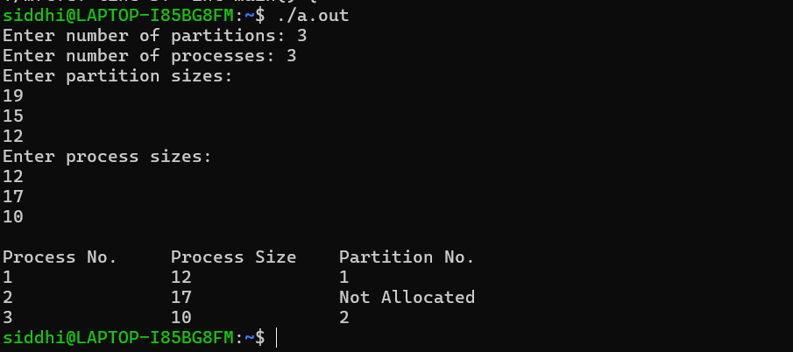
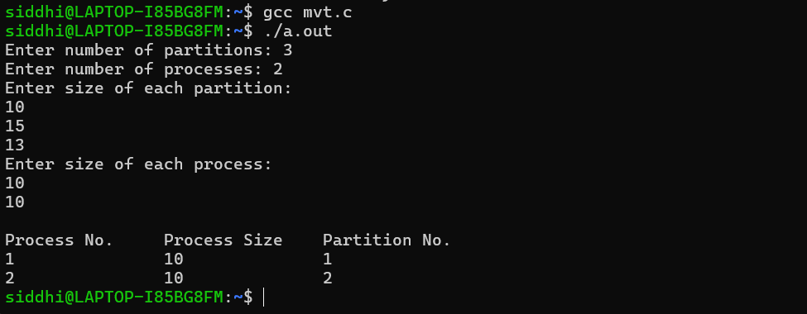
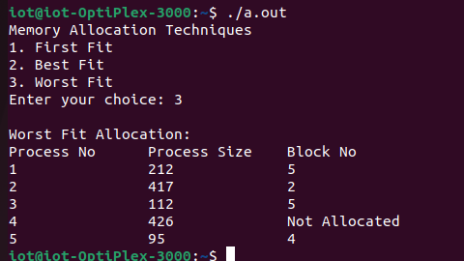

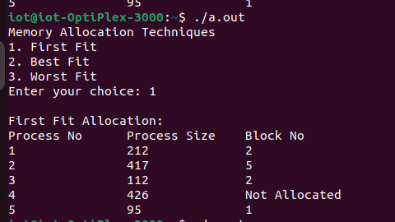


CONCLUSION:
A]
- MFT divides memory into fixed-size partitions, which can lead to internal fragmentation but simplifies allocation.
- MVT allocates memory dynamically based on process size, reducing internal fragmentation but may lead to external fragmentation.
B]
- First Fit allocates the first sufficiently large block, which is fast but may leave small unusable holes.
- Best Fit allocates the smallest adequate block, minimizing wasted memory but may cause more external fragmentation over time.
- Worst Fit allocates the largest available block, which may leave moderately sized free spaces but reduces the chance of tiny unusable fragments.
- The program demonstrates how each algorithm impacts memory utilization, fragmentation, and allocation efficiency.

